Week 1: Algorithms_Data Structures
Exercise 2 Solution: E-commerce Platform Search Function
- Big O notation is a mathematical tool used to describe how an algorithm’s runtime or memory requirements increases as the input data grows.
It generally represents the worst case, and helps us compare algorithms and find out which algorithm performs better for large datasets.
- Best Case Scenario for search operation:
The item is found immediately.
Example:
Products: [101,102,103,104,105]
Search: 101 (Found at first position.)
Time Complexity: O(1)
Average Case Scenario for search operation:
The item is somewhere in the middle.
Example:
Products: [101,102,103,104,105]
Search: 103 (Need to check a few elements)
Time Complexity: O(n)
Worst Case Scenario for search operation:
The item is at the last position or doesn't exist.
Example:
Products: [101,102,103,104,105]
Search: 105 or 999 (Need to check every element.)
Time Complexity: O(n)
- Output:
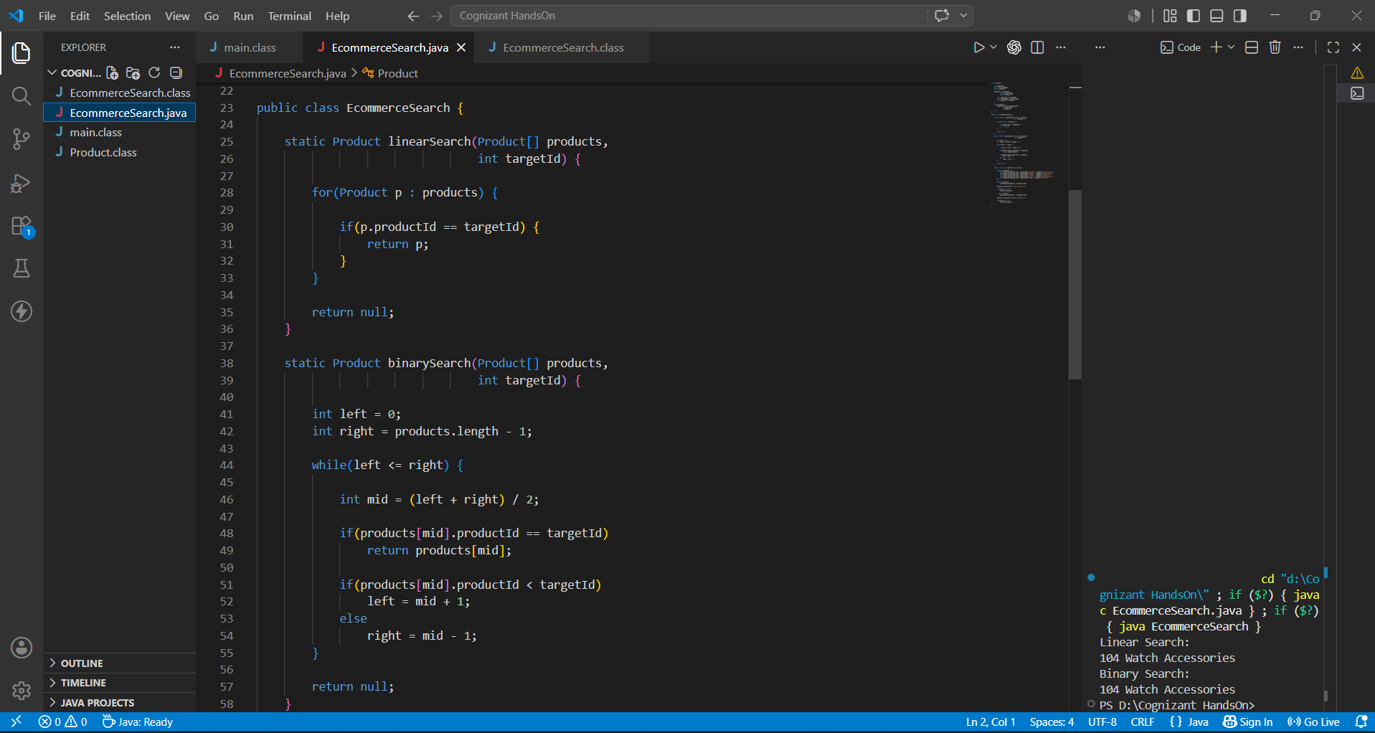

- For Linear Search: Best Case :- O(1)
Average Case :- O(n)
Worst Case :- O(n)
- For Binary Search: Best Case :- O(1)
Average Case :- O(log n)
Worst Case :- O(log n)
- For an ecommerce site, binary search is best because if we need to search 1000 elements, in worst case scenario, linear search will iterate through all 1000 elements. But binary search will roughly make 20 iterations to find the element. That’s why Binary Search is best.

Exercise 7 Solution: Financial Forecasting
- Recursion is basically a program in which a function calls itself until it reaches a stopping condition called base case.
Instead of using loops, we can use recursive techniques as it is faster when working on complex tree/graphs.
Recursion is mainly useful when a problem can be broken down into smaller problems, making it easier to understand and implement.

- Setup:
Assume: Current Value: rs 10,000
Growth Rate = 10% per year
Years: 3
Recursive logic : Future Value = Current Value * 1+Growth Rate)

- Output:
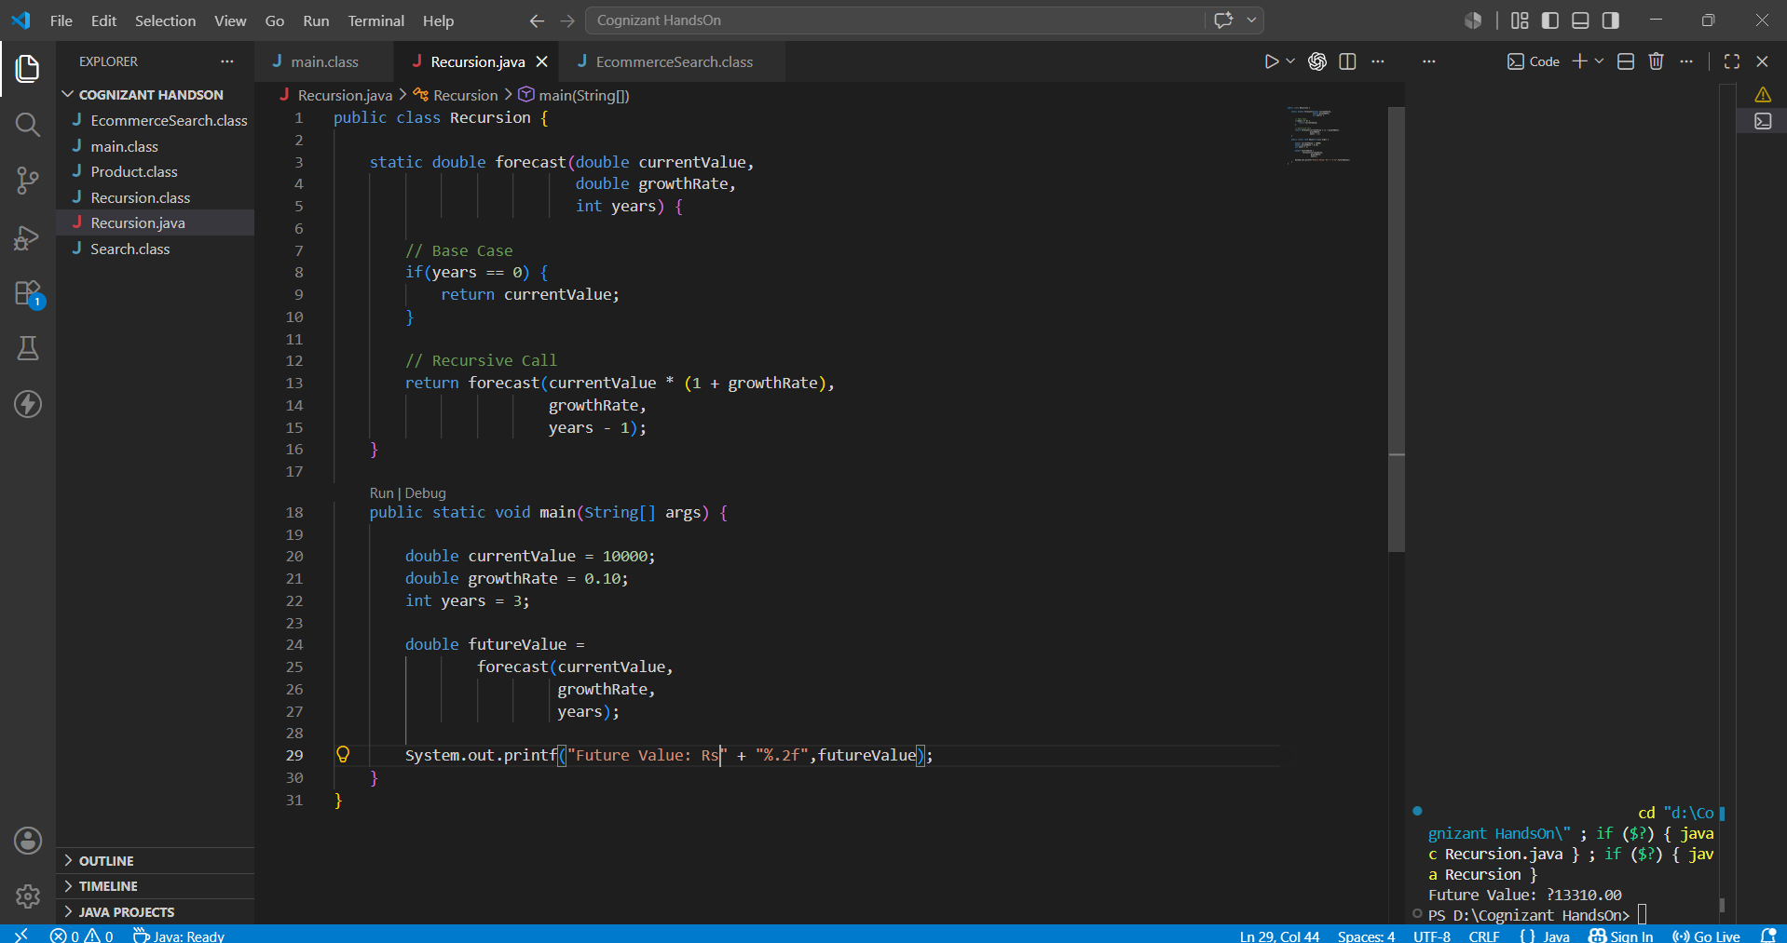

- Analysis:
For time complexity, this method makes one recursive call for each year.
Therefore for n years, time complexity is O(n).
For Space Complexity, each recursive call is stored in memory until the base case is reached.
Space Complexity = O(n).

- Recursive methods can be optimized by using memorization, storing previously calculated results.
Also, by using a mathematical formula whenever possible.
Or simply by using an iterative loop instead of recursion if the problem doesn’t go well with recursion.

